Edureka Industrial Grade Project

Contributor: Rakesh Ranade

Version 1

Document History
Date | Description | Author
02/12/2025 | Created | Rakesh Ranade

Introduction:

This document contains information regarding the project work completed for Edureka DevOps certification. Goal of this project is to develop a deployment pipeline using git as a source repository, jenkings as a CI/CD pipeline and docker as its image creation tool. At the end the same image is deployed at microk8s on the same machine

Flow of Pipeline

- Pull Source from Repository
- pull a docker image from microsofts images
- copy source to image
- restore packages and build code in the image
- start a container using that image
- use curl command to perform a healthcheck on the website
- publish the image to docker hub
- deploy image to microk8s

a sample build log is also added to github repo to view the results

Environment/Inventory:

# | Description
1 | GitHub repository | https://github.com/rakeshranade/Edureka-IGP1
2 | Docker Registry | https://hub.docker.com/r/rranade/edureka-igp
3 | Jenkins | Running on a Ubuntu VM
4 | Docker | Installed and configured on same VM
5 | Microk8s | Installed and running on same VM
6 | Jenkins File | [source_root]/.jenkins/jenkinsfile
7 | Docker File | [source_root]/.docker/igp1.dockerfile
8 | Deployment.yaml | [source_root]/.jenkins/.Kubernetes/deployment.yaml
9 | Services.yaml | [source_root]/.jenkins/.Kubernetes/services.yaml
10 | Build Log Output | [source_root]/Documentation/Jenkins_build_log_33.txt
11 | Documents | [source_root]/Documentation

Installation Process…

1 | Ubuntu VM Created on Proxmox
 | 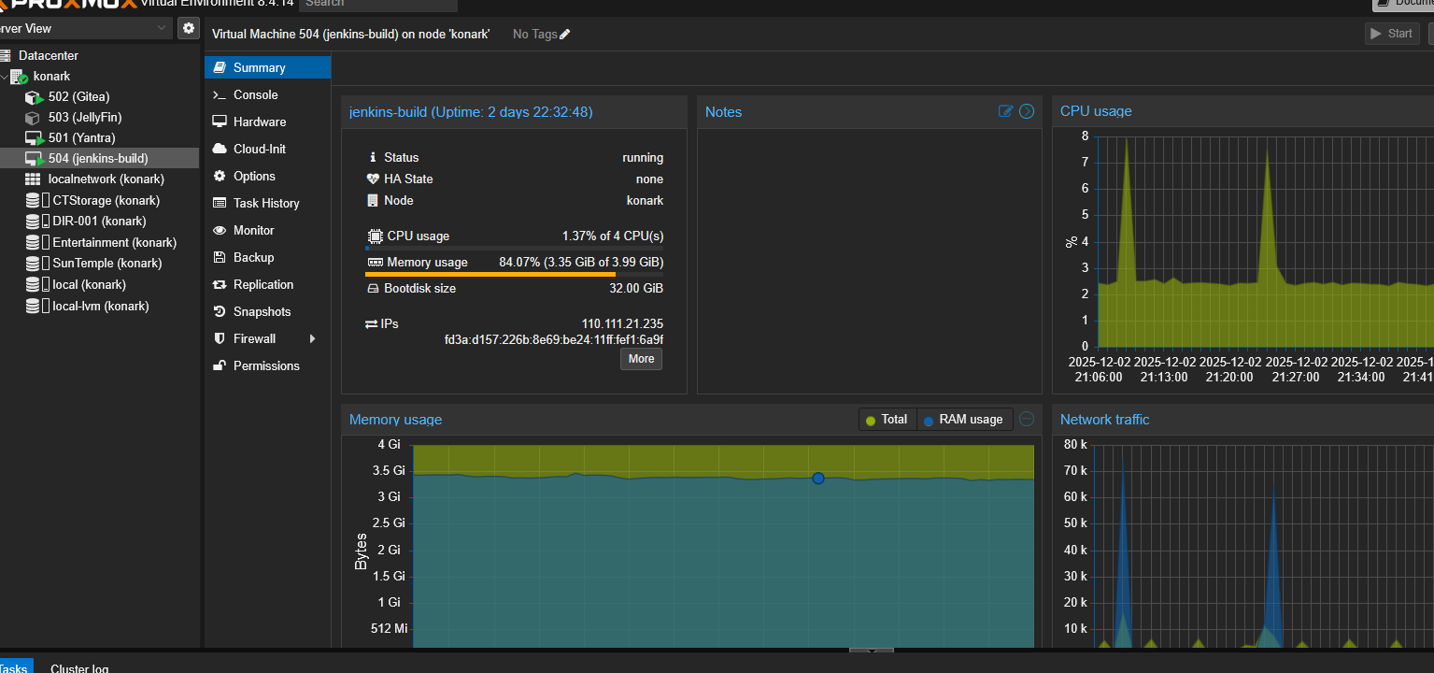
2 | Jenkins Installed and Running  Documentation: https://www.jenkins.io/doc/book/installing/linux/  Commands Used:  sudo wget -O /etc/apt/keyrings/jenkins-keyring.asc \  https://pkg.jenkins.io/debian-stable/jenkins.io-2023.key  echo "deb [signed-by=/etc/apt/keyrings/jenkins-keyring.asc]" \  https://pkg.jenkins.io/debian-stable binary/ | sudo tee \  /etc/apt/sources.list.d/jenkins.list > /dev/null  sudo apt update  sudo apt install jenkins
 | 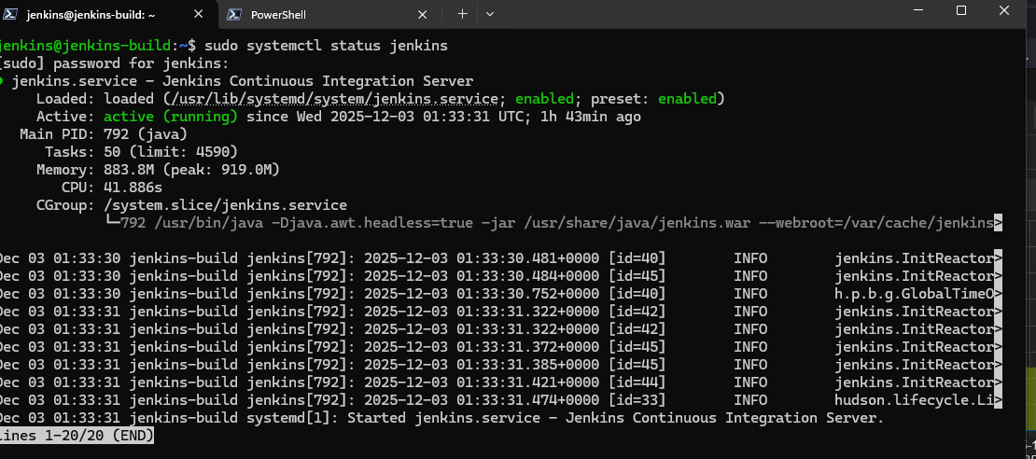
3 | Docker Installed and Running  Documentation: https://docs.docker.com/engine/install/ubuntu/  Commands Used:  sudo apt install apt-transport-https ca-certificates curl software-properties-common  curl -fsSL https://download.docker.com/linux/ubuntu/gpg | sudo gpg --dearmor -o /usr/share/keyrings/docker-archive-keyring.gpg  echo "deb [arch=$(dpkg --print-architecture) signed-by=/usr/share/keyrings/docker-archive-keyring.gpg] https://download.docker.com/linux/ubuntu $(lsb_release -cs) stable" | sudo tee /etc/apt/sources.list.d/docker.list > /dev/null  sudo apt update  sudo apt install docker-ce docker-ce-cli containerd.io docker-buildx-plugin docker-compose-plugin  sudo usermod -aG docker $USER  sudo docker run hello-world
 | 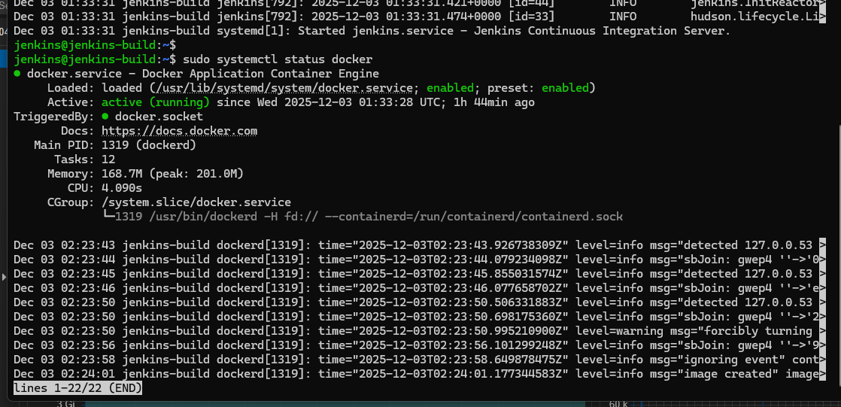
4 | Jenkins Pipeline Configured
 | 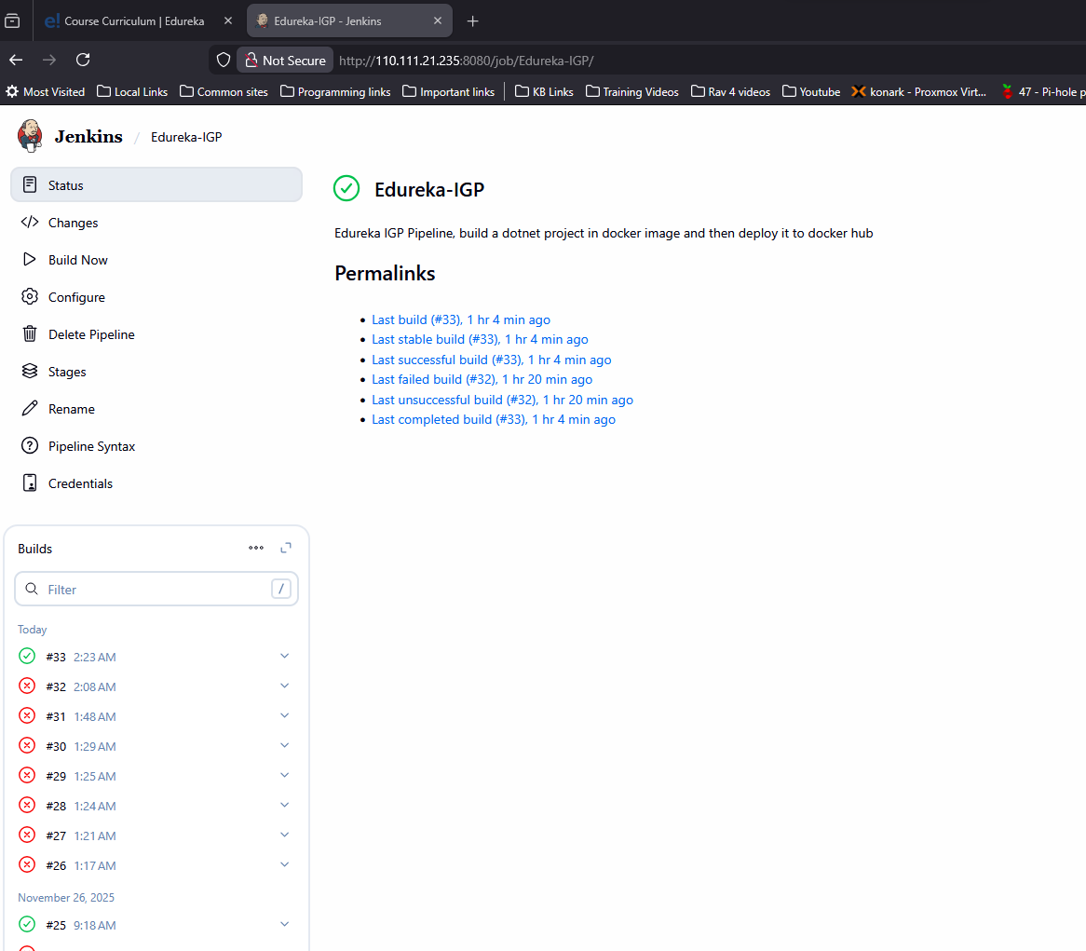
 | 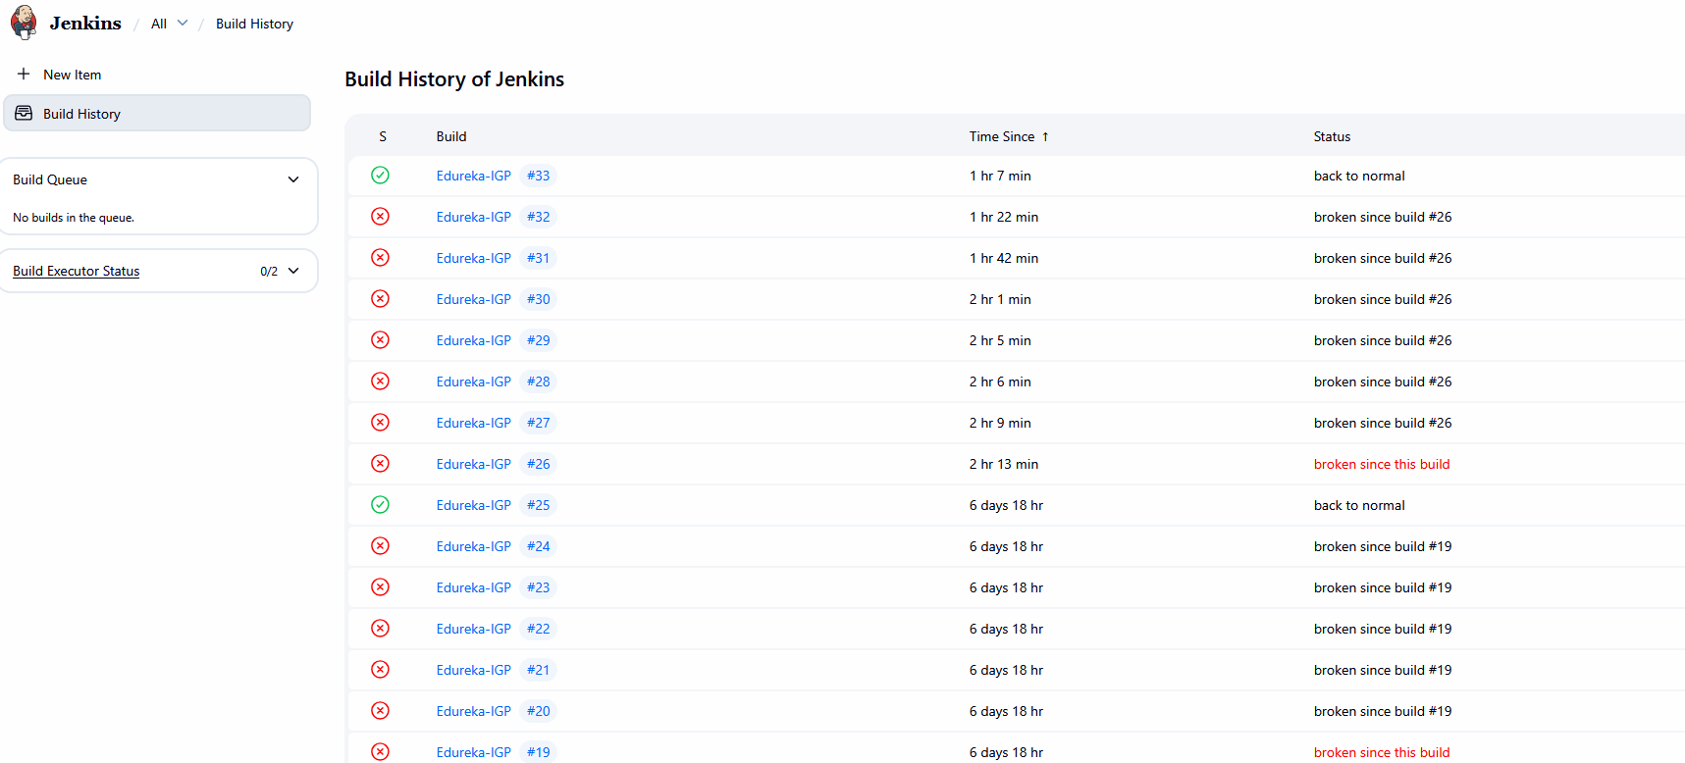
 | Jenkins pipeline is configured to pull the pipeline file from github repository
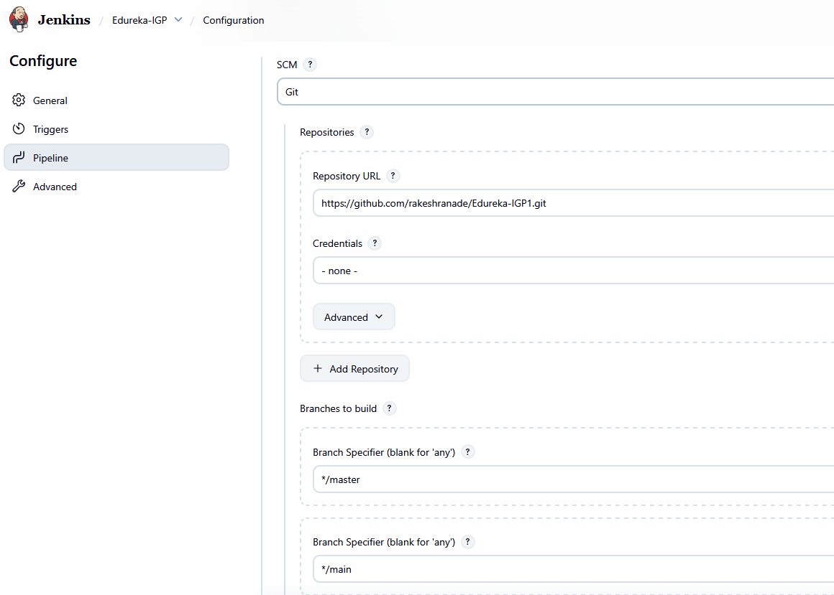
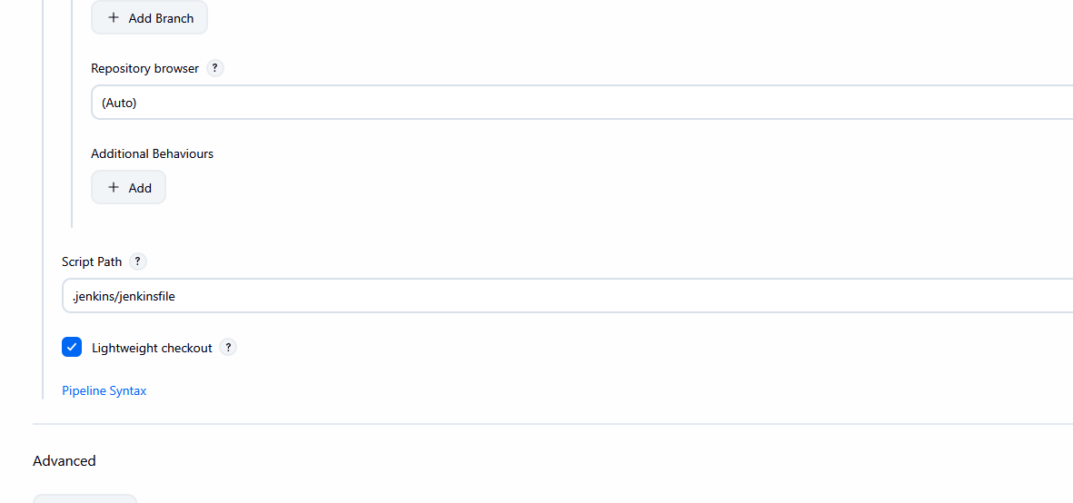
 | Additional commands used while testing
docker build -f .docker/igp1.dockerfile -t edureka-igp1:7 .

docker run -it --name igp edureka-igp1:7 /bin/bash
dotnet publish /src/src/Edureka-igp1/Edureka-igp1.csproj -c Release -o /app/publish --no-restore -p:PublishTrimmed=true --runtime linux-x64
dotnet build --runtime linux-x64 -c Debug -o ~/app/debug ./Edureka-igp1.csproj

docker run -d -p 8090:5000 --name edureka-igp edureka-igp1:7

http://localhost:8090/Privacy

